№14

1. Cloud technologies (computing) make it possible to eliminate the risk of data loss.

2. Hard drives are sensitive to vibration, especially during operation.

3. Formatting deletes all existing files on the disk.

4. External hard drives are usually used for backup.

5. The hard drive can hold hundreds of gigabytes of data.

6. Unlike RAM, flash memory is non-volatile.

7. Disk fragmentation occurs as a result of multiple changes and deletion of files.

8. Optical discs should not be exposed to high temperature and direct sunlight.

9. CD and DVD discs differ in their internal structure and in the amount of data storage

№1

**What is software?** Software refers to a collection of programs, data, and instructions used to operate computers and perform specific tasks. It includes applications, operating systems, utilities, and other elements that enable hardware to function.

**Which operating systems are most often used nowadays?** Currently, the most commonly used operating systems are Microsoft Windows, macOS (for Apple computers), and various distributions of Linux. Windows dominates the PC market, macOS is popular among Apple users, and Linux, in its different distributions like Ubuntu, Fedora, and Debian, is widely used in servers, embedded systems, and by tech enthusiasts due to its open-source nature.

**What application do you often use in your work or studies? Talk about its main features.** One of the primary tools I use is a browser, which allows me to access information, conduct research, and interact with various online resources. Its key features include navigating the internet, accessing websites, utilizing bookmarks, managing tabs, and enabling extensions for added functionality.

№2

Программное обеспечение — это набор инструкций, правил или программ, используемых для управления компьютерной системой и инструктирующих систему выполнять конкретные задачи. Другими словами, программное обеспечение — это общий термин, который относится к любым программам, запущенным на настольных ПК, ноутбуках, смартфонах или других компьютерных устройствах. Программное обеспечение можно разделить на две основные категории: системное программное обеспечение и прикладное программное обеспечение.

Системное программное обеспечение — это программное обеспечение общего назначения, которое используется для управления компьютерным оборудованием. Оно действует как интерфейс (т.е. обеспечивает связь) между прикладными программами и компьютерным оборудованием. Системное программное обеспечение предназначено для управления системными ресурсами и предоставления платформы для запуска прикладного программного обеспечения. Некоторые распространенные примеры системного программного обеспечения включают:

* Операционные системы (набор программ, которые управляют компьютерным оборудованием и программными ресурсами);
* Встроенное ПО (постоянное программное обеспечение или набор инструкций, хранящихся в ПЗУ (постоянной памяти) компьютерной системы);
* Драйверы устройств (тип программного обеспечения, которое управляет определенным оборудованием компьютерной системы).

Системное программное обеспечение обычно пишется на языках низкого уровня, таких как языки ассемблера, чтобы оно могло взаимодействовать с оборудованием с максимально возможной скоростью и обеспечивать эффективную платформу для прикладных программ.

Прикладное программное обеспечение предназначено для того, чтобы помочь пользователю выполнить определенную задачу, поэтому оно известно как программное обеспечение специального назначения. В отличие от системного программного обеспечения, которое работает в фоновом режиме, прикладное программное обеспечение обычно запускается во внешнем интерфейсе, что делает его более доступным для пользователя. Следует отметить, что прикладное программное обеспечение не может запускаться само по себе, для этого требуется платформа, созданная системным программным обеспечением. Прикладное программное обеспечение обычно пишется на языках высокого уровня, таких как Java или C++.

Наиболее распространенными типами прикладного программного обеспечения являются:

* Текстовые процессоры, которые используются для создания документов, а также редактирования, форматирования и вывода текста (например, MS Word, Google Docs);
* Программное обеспечение для баз данных, которое помогает в создании баз данных и управлении ими (например, Oracle, MySQL);
* Веб-браузеры, которые в основном используются для серфинга в Интернете, чтобы помочь пользователю найти определенные веб-адреса или получить данные в Интернете (например, Google Chrome, Internet Explorer).

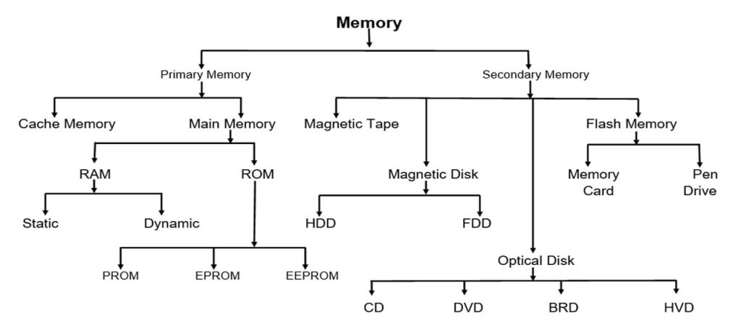

1. ROM (Read-Only Memory):

* Read-only.
* Immutable information during recording.
* It is used to store persistent data and programs.

2. RAM (Random-Access Memory):

* A general term for a type of memory that can be accessed randomly to read and write data.
* It is able to quickly read and write data, but loses information when the power is turned off.
* They are divided into two main subtypes: DRAM (Dynamic RAM) and SRAM (Static RAM).
* It is used for temporary storage of data and programs during the operation of a computer or other electronic devices.
* The most common type of RAM for desktop computers is DDR4 and the latest systems may use DDR5(higher data transfer rate, higher clock speeds, more energy-efficient).

SRAM (Static Random-Access Memory):

* Stores data in the form of bistable elements (for example, triggers).
* It does not require periodic updates, which provides faster access to data.
* Faster, but less dense compared to DRAM.

DRAM (Dynamic Random-Access Memory):

* Stores data in the form of a charge in the capacitance of the capacitor.
* Requires periodic activation (updates) to retain data.
* Higher storage density, but slower compared to SRAM.

SDRAM (Synchronous Dynamic Random-Access Memory):

* Synchronous Operation: It synchronizes with the system clock, enhancing data transfer speeds by coordinating with the system's clock cycle.
* Higher Transfer Rates: SDRAM operates at higher frequencies compared to older memory types, boosting memory bandwidth and overall system performance.

MROM (Masked ROM):

* This is a type of Read-Only Memory in which program data is pre-recorded during chip production.
* Does not provide the ability to overwrite data.
* It is used for permanent storage of fixed programs and data.
* The need for a mask (template) in the production process makes MROM less flexible compared to programmable ROMs.

PROM (programmable read-only memory) – программируемое постоянное запоминающее устройство:

* Recorded once by the user.
* After programming, the data remains unchanged.

EPROM (erasable programmable read-only memory) – стираемое программируемое постоянное запоминающее устройство:

* Recorded by the user and reprogrammable after erasing.
* It is erased using ultraviolet light.
* Used for development and testing.

EEPROM (electrically erasable programmable read only memory) - электронно-стираемое программируемое постоянное запоминающее устройство:

* Recorded and reprogrammable electrically.
* Does not require UV light to erase.
* It is used in applications where frequent data changes are required.

FLASH Memory:

* A contemporary variety of EEPROM
* Quick access to data.
* Allows multiple overwriting by blocks (sectors).
* It is widely used in modern devices for storing programs and data, such as USB drives, SSDs and microcontrollers.

Magnetic storage devices (magnetic tapes, floppy disks, hard disk drives) store data by magnetizing particles on a disk or tape. A floppy disk was so called because it consisted of a flexible sheet of plastic, coated with iron oxide — a magnetizable material. A floppy disk

could spin at 360 revolutions per minute and store 1.44 MB of data.

A hard drive, however, can store much more data and retrieve information much faster. It consists of several plates that are made up of a magnetic material and known as platters.

The surface of the magnetic plate is divided into billions of tiny compartments where data is stored. When data is recorded on an HDD, it is converted from the digital form into the analogue form (magnetized area). Magnetized tiny area of the plate denotes a binary one; whereas, the demagnetized tiny area denotes a binary zero. Hard drives are very sensitive to vibration and shocks, especially when they are operating; when the read/write head touches the rotating disk, it can scratch and damage the disk surface.

Optical storage is any storage type in which data is written as a series of reflective marks and read with a laser.

* The CD (Compact Disc) represents the first generation of optical storage. Originally, CDs were available only as prerecorded read-only discs, but it wasn't long before they became available as recordable discs (CD-R) and rewritable discs (CD-RW) that could be used for data storage. The CD can hold up to 700 megabytes of data.
* At first sight, the DVD (Digital Versatile Disc) is similar to the CD. Both discs are 120 mm in diameter and 1.2 mm thick. They also both use a laser beam to read data. However, they are very different in internal structure and data capacity. In a DVD, the tracks are very close together, thus allowing more tracks. The pits in which data is stored are also smaller, so there are more pits per track.
* The Blu-ray disc has emerged as clear leader in today's optical storage market. Unlike CDs and DVDs, which use a red laser to read and write data, a Blu-ray disc uses a blue laser, which dramatically increases capacities and data transfer rates over CDs and DVDs. Among disadvantages of optical storage one can name its speed and capacity.

A solid-state drive (SSD) is a type of non-volatile storage media that uses integrated circuit

assemblies to store data persistently. Two key components make up an SSD: a flash controller and

flash memory chips. The architectural configuration of the SSD controller is optimized to deliver high read and write performance. Unlike a hard disk drive (HDD), an SSD has no moving parts that can break if dropped. Because of this, SSDs can be subjected to much more shock and vibration than a hard drive, making them ideal for a broad range of portable and mobile devices.

Whereas a spinning HDD reads and writes data magnetically, an SSD reads and writes the data to interconnected flash memory chips, which are fabricated out of silicon.